DEPARTMENT OF
COMPUTER SCIENCE & ENGINEERING
Dr. A. D. SHINDE COLLEGE OF ENGINEERING, BHADGAON
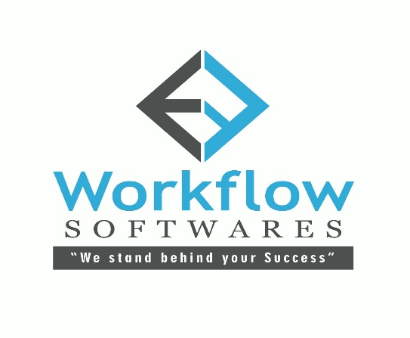
INTERNSHIP REPORT
ON
DATA ANALYSIS
A report submitted in partial fulfillment of the requirements of Internship
for
Bachelor of Technology
in
Computer Science Engineering
by
Bushra Riyazahahamed Nadaf
PRN. No: 2024068305
(Training Duration: 60 Days)

Submitted To:_ Internship Guide:-
Prof. Richa Jadhav Mr. Rizwan Kumnali
(Head of Department) Founder & CEO
Computer Science & Engineering Workflow Softwares, Sankeshwar

ABSTRACT
This report presents the internship training completed at Workflow Softwares in the domain of Data Analytics using Python. The internship was conducted from 09 June 2026 to 17 August 2026 in offline mode.
The training focused on developing practical skills in data analytics, including data cleaning, exploratory data analysis, data visualization, and dashboard creation. Various tools such as Python, SQL, Excel, and Power BI were used to perform real-world data analysis tasks.
The internship included hands-on projects such as Computers Sales & Services Analysis, where data was processed, analyzed, and visualized to generate meaningful insights. The program also emphasized soft skills such as communication, teamwork, and presentation.
Overall, the internship helped in bridging the gap between academic learning and industry requirements, enhancing both technical and professional competencies.

CHAPTER 1: INTRODUCTION

Background of the Organization
In today’s digital era, data has become one of the most valuable assets for organizations. Companies rely on data analytics to make informed decisions, improve efficiency, and gain competitive advantage. With the increasing demand for data-driven decision-making, the need for skilled data analysts has significantly grown.
Workflow Softwares Solution is a growing software research and development company that focuses on providing industry-oriented training and real-time project exposure to students. The organization aims to bridge the gap between academic learning and industry requirements by offering practical training programs.

Company Profile

The company is equipped with experienced and highly skilled professionals who have expertise on variety of tools and platforms. The professionals keep them updated with the latest technologies so that the most modern solutions can be provided to the clients. Each individual associated with the organization is inspired by the motto to offer impeccable IT Solutions that are innovative and cost effective. The achievement of the company is rooted in its customer-centric approach. It emphasizes on offering customized solution so that the exact requirements of the clients can be met. After carefully examining the requirements, the company formulates strategies for successful completion of the projects. By choosing Workflow Softwares you get more than our web programming and design work. You also get our years of experience and expertise, in developing a Web site or Application unique to your business needs. Workflow Softwares is an innovative technology industry focused, business driven professional services firm. From web design and web development to custom Php, Asp and Jsp applications development and Android Development, our talented people work intelligently to solve and manage client's needs We serve to deliver cost effective interactive technology and design solutions without compromising on quality. With clients globally, high-performance Websites for companies in multiple industries including hospitality, retail, wholesale, and communications and so on.

Company Name | Workflow Softwares
Type | Information Technology (IT)
Founder | Rizwan Kumnali
Contact No | +91-8147817232
Email | workflowsofts.rizwan@gmail.com
Website | https://workflowsoftwares.in
Est. Year | 2018
Location | Sankeshwar, Karnataka

Vision:

Our Vision is as a major IT service provider to become a leading performer, in providing quality Web and Software Development solutions by using Modern Software Engineering Methodologies to assure that every business we provide is of the Leading Quality and that each project is Delivered On-Time and in-Budget And also We have the ability to accelerate and quickly share the great work or products of your organization or business. We provide hands-on experience to the students.

Mission:

To provide an attractive IT services for your business purposes to compete and motivate team members using the art technology to maintain stability and the growth of the organization in IT sectors by providing most advantageous IT solutions to all.

Services Provided By Company
- Web Designing and development
- Customized Software development
- Android Apps Development.
- Digital Marketing & SEO (Search Engine Optimization)
- Real time Academic Projects Training
- Real time Internships and Training
- Graphics Designing (Banners, Templates & Logos)
Products and Projects Done by Company
- Sanadi Auto Care, Chikodi - Billing Software
- A3 Services, Gadhinglaj - Food Delivery Dynamic Website and Android App
- SJPN Degree College, Nidasoshi - Website
- SJPN PU College, Nidasoshi- Website
- Krishna Ayurvedic Medical College, Sankeshwar- Dynamic Website
- Jyotiraj Chit Funds, Sankeshwar- Application Software
- Ignite Gym & Bison Gym, Sankeshwar- Gym Management

Internship Objectives
The internship was designed with the following objectives:

    - To develop a strong foundation in Data Analytics concepts

    - To gain practical experience in handling real-world datasets

    - To learn data cleaning, preprocessing, and transformation techniques

    - To develop visualization and dashboard skills using Power BI

    - To improve problem-solving and analytical thinking

    - To gain industry exposure and professional experience

CHAPTER 2: INTERNSHIP DETAILS
  - Internship Overview
In ongoing internship, I am working as an intern in Workflow Softwares, and I am currently working in live project as an Data Analyst using variety of tools and technologies like Python, MS-Excel, SQL and Power BI.
Details are given below:
Name | Bushra R. Nadaf
Intern ID | WFSINT7551
Designation | Intern
Date of Joining | 9th June, 2026
Date of Reliving | 10th August, 2026
Internship Mode | Offline
Location | Sankeshwar

The internship program followed a structured approach where learning progressed from basic concepts to advanced applications.

Roles and Responsibilities
During the internship, several responsibilities were undertaken:

    - Collecting and understanding datasets from various sources

    - Cleaning and preprocessing data to remove inconsistencies

    - Writing SQL queries for data extraction and manipulation

    - To get Exploratory Data Analysis [EDA]

    - Creating visualizations using Python libraries

    - Designing dashboards using Power BI

    - Working on mini projects and real-world case studies

    - Presenting insights through reports and presentations

Tools and Technologies Python
Python is widely used in data analytics due to its simplicity and powerful libraries. It was used for data cleaning, analysis, and visualization.

Pandas
Pandas provides Data Frame structures that help in handling structured data efficiently. It was used for filtering, grouping, and transforming data.

Num Py
NumPy supports numerical computations and array operations, making data processing faster and efficient.

Matplotlib & Seaborn
These libraries were used to create visual representations such as bar charts, Pie charts, line graphs, and heatmaps.

SQL
SQL was used to query databases and retrieve structured data using commands like SELECT, JOIN, and GROUP BY

Power BI
Power BI was used to create interactive dashboards and reports for better visualization and decision-making.

CHAPTER 3: WORK / TASKS UNDERTAKEN

Data Cleaning and Preprocessing
Data cleaning is a crucial step in data analytics. During the internship:

    - Missing values were handled

    - Duplicate data was removed

    - Incorrect data formats were corrected

    - Data was transformed into usable format

This process ensured accuracy and reliability of analysis.

Exploratory Data Analysis (EDA)
EDA was performed to understand the dataset and extract insights:

    - Identified patterns and trends

    - Analyzed relationships between variables

    - Detected outliers

    - Used statistical measures like mean, median, and variance

Data Visualization
Visualization helps in understanding complex data easily:

    - Bar charts for comparisons

    - Line graphs for trends

    - Pie charts for distribution

    - Heatmaps for correlations

SQL Operations
SQL queries were used to:

    - Retrieve data from databases

    - Filter data based on conditions

    - Join multiple tables

    - Aggregate data using functions

Projects Undertaken
Project: Workflow Computers Sales and Services Analysis
This project focused on analyzing Computer Sales & Service to identify patterns: Here, we have to collect the real time data from the client of based on date we have in prepare real time interactive dashboard, which can showcase total sales, profit, ratio in proper report format.
To prepare this project we must need this data
1] Business details - Trade name - Established date & year - owner name - contact number - business address
2] Products
3] Customer details
4] Orders (Sales)
5] Servicing details (Repair)

CHAPTER 4: LEARNING OUTCOMES

Technical Skills Gained
During the internship, I gained strong technical knowledge in the field of Data Analytics. I developed hands-on experience in working with tools such as Python, SQL, Excel, and Power BI.
I learned how to perform data cleaning and preprocessing using libraries like Pandas and NumPy. I also gained practical exposure to Exploratory Data Analysis (EDA), where I analyzed datasets to identify patterns, trends, and insights.
Additionally, I improved my data visualization skills by creating charts and dashboards using Matplotlib, Seaborn, and Power BI. I also learned how to write efficient SQL queries for data extraction and manipulation.
Overall, the internship helped me build a solid foundation in handling real-world data and transforming it into meaningful insights.

Soft Skills Developed
During the internship, significant emphasis was placed on developing professional soft skills that are essential in the data analytics industry. These skills are critical for effective collaboration, communication, and successful project delivery.

Communication Skills

I developed strong communication skills by regularly presenting my analysis, insights, and project outcomes to mentors and peers. This included explaining complex data findings in a simple and understandable manner using visualizations and reports.
I also improved my written communication through documentation, report writing, and dashboard annotations. Learning to tailor communication based on the audience (technical vs non-technical stakeholders) was a key takeaway, as it is essential in real-world business environments.

Teamwork and Collaboration

During the internship, I worked in a collaborative environment where teamwork played a crucial role. I participated in group discussions, shared ideas, and contributed to project tasks collectively.

I learned how to coordinate with team members, respect diverse perspectives, and support others in achieving common goals. This experience enhanced my ability to work efficiently in team-based projects, which is a standard practice in the IT and Analytics industry.

Time Management and Meeting Deadlines

The internship required completing tasks within strict timelines, which helped me develop effective time management skills. I learned to prioritize tasks based on urgency and importance, ensuring that project milestones were achieved on time.
By planning daily activities and setting realistic goals, I was able to manage multiple assignments simultaneously without compromising quality. Meeting deadlines consistently is a critical industry expectation, and this experience helped me build that discipline.

Problem-Solving and Analytical Thinking

Working with real-world datasets often involved dealing with incomplete, inconsistent, or complex data. This helped me develop strong problem-solving abilities.
I learned to approach problems logically by breaking them down into smaller components, analyzing patterns, and applying appropriate techniques to resolve issues. This analytical mindset is essential in data analytics roles where decision-making is data-driven.

Adaptability and Continuous Learning

The internship environment required adapting to new tools, technologies, and problem scenarios. I demonstrated flexibility by quickly learning new concepts such as advanced data visualization techniques and SQL queries.

I also developed a habit of continuous learning by exploring online resources, documentation, and practice datasets. This adaptability is highly valued in the industry, where technologies and requirements evolve rapidly.

Professionalism and Work Ethics

I maintained a professional approach throughout the internship by being punctual, responsible, and committed to my tasks. I followed instructions carefully, respected organizational guidelines, and maintained discipline in my work.
Developing a strong work ethic, including accountability and attention to detail, is essential for building a successful career in the corporate environment.

Industry Exposure
The internship provided valuable exposure to real-world industry practices. I understood how data analytics is applied in business decision-making.
I worked on real datasets and projects, which gave me insight into industry workflows such as data collection, preprocessing, analysis, and reporting.
I also became familiar with professional tools and standards used in the IT industry, which helped bridge the gap between academic learning and practical application.

CHAPTER 5: CHALLENGES & SOLUTIONS

Difficulties Faced
During the internship, I encountered several challenges:

    - Handling datasets with missing or inconsistent values

    - Understanding complex data patterns during EDA

    - Writing optimized SQL queries

    - Designing effective and meaningful visualizations

    - Managing time between multiple tasks and deadlines

These challenges initially made it difficult to proceed smoothly with the tasks.

How Challenges Were Overcome
I overcame these challenges through continuous learning and practice:

    - Referred to online resources and documentation to understand concepts better

    - Took guidance from mentors and trainers whenever required

    - Practiced coding and data analysis regularly

    - Broke complex problems into smaller manageable parts

    - Improved time management by planning daily tasks

These approaches helped me gain confidence and improve my performance over time.

CHAPTER 6: CONCLUSION & FUTURE SCOPE

Summary of Learning
The internship at Workflow Softwares was a valuable learning experience. It helped me gain practical knowledge in data analytics and improve both technical and soft skills.
I learned how to work with real-world data, perform analysis, and present insights effectively using various tools and technologies.

Application to Academics & Career
The knowledge gained during this internship will be highly beneficial for my academic projects and future career.
It has strengthened my understanding of data analytics concepts and prepared me for roles such as Data Analyst or Business Analyst. The hands-on experience will also help me perform better in future internships and job opportunities.

Suggestions for Future Interns
Based on my experience, I would like to suggest the following for future interns:

    - Focus on understanding the basics before moving to advanced topics.

    - Practice regularly to improve technical skills.

    - Actively participate in projects and discussions.

    - Seek guidance from mentors whenever needed.

    - Work on improving both technical and communication skills.

    - Workflow Softwares provides excellent hands-on training with real-time project exposure, making it highly beneficial for skill development. Future interns are strongly encouraged to choose this organization to gain practical industry experience and enhance their career readiness.
Following these suggestions will help future interns make the most out of their internship experience.

Work Screenshots:

Histogram chart:
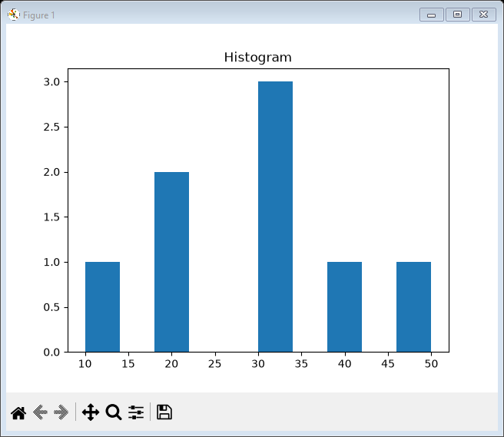

Pie Chart:

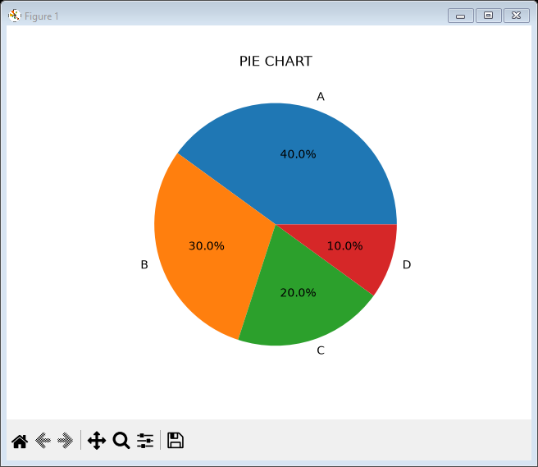

Sales Project:

